Chapter 4, Solution 3.

(b)
1 V

+
−
3R
1.5R
(a)
V_{s}

+
−
R
R
3R
3R
i_{o}
3R
+
v_{o}
−

- We transform the Y sub-circuit to the equivalent .

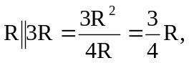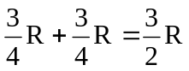
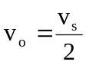 independent of R
i_{o} = v_{o}/(R)

When v_{s} = 1V, v_{o} = 0.5V, i_{o} = 0.5A

- When v_{s} = 10V, v_{o} = 5V, i_{o} = 5A
- When v_{s} = 10V and R = 10Ω,
v_{o} = 5V, i_{o} = 10/(10) = 500mA

